1. Create a React project named “scorecalculatorapp” type the following command in terminal of Visual studio:

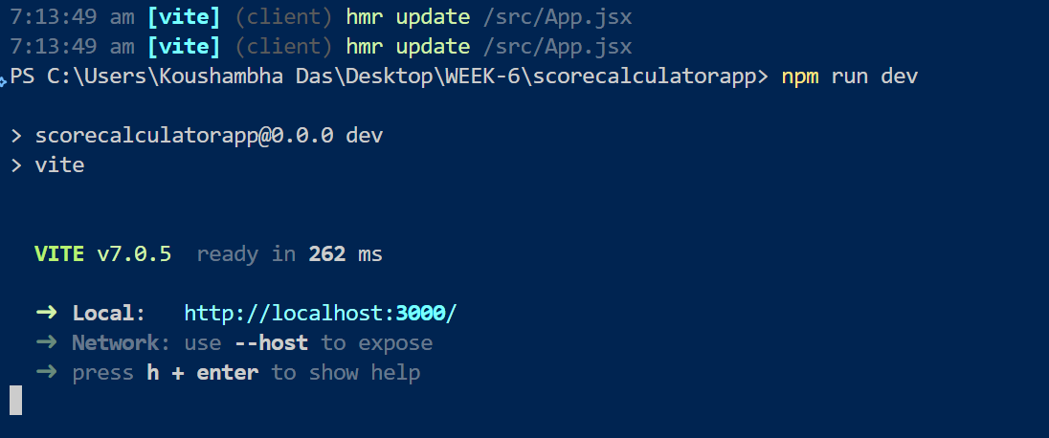  
  
  
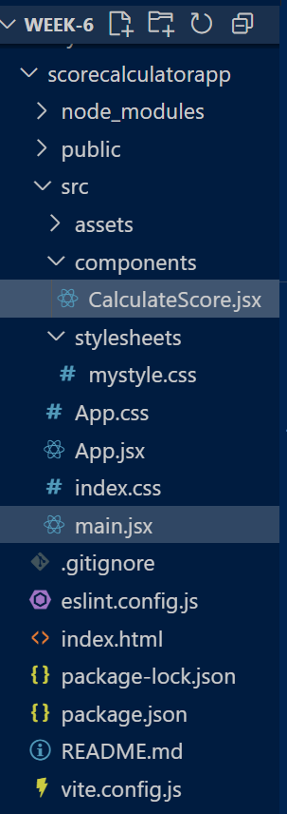  
  
  
  
**CalculateScore.jsx:**

import '../stylesheets/mystyle.css';

const percentToDecimal = (decimal) => {

  return (decimal * 100).toFixed(2) + '%';

};

const calcScore = (total, goal) => {

  return percentToDecimal(total / goal);

};

const CalculateScore = ({ Name, School, total, goal }) => {

  return (

    <div className="formatstyle">

      <h1 style={{ color: "brown" }}>Student Details:</h1>

      <div className="Name">

        <b><span>Name: </span></b>

        <span>{Name}</span>

      </div>

      <div className="School">

        <b><span>School: </span></b>

        <span>{School}</span>

      </div>

      <div className="Total">

        <b><span>Total: </span></b>

        <span>{total}</span>

        <span> Marks</span>

      </div>

      <div className="Score">

        <b>Score: </b>

        <span>{calcScore(total, goal)}</span>

      </div>

    </div>

  );

};

export default CalculateScore;

**mystyle.css:**.Name {

  font-weight: 300;

  color: blue;

}

.School {

  color: crimson;

}

.Total {

  color: darkmagenta;

}

.formatstyle {

  text-align: center;

  font-size: large;

}

.Score {

  color: forestgreen;

}

